**Parent Job Aid for Accessing Ren 360 Parent Score Reports in Skyward – Family Access.**

1. Log into Family Access at <https://www.fortbendisd.com/family-access>

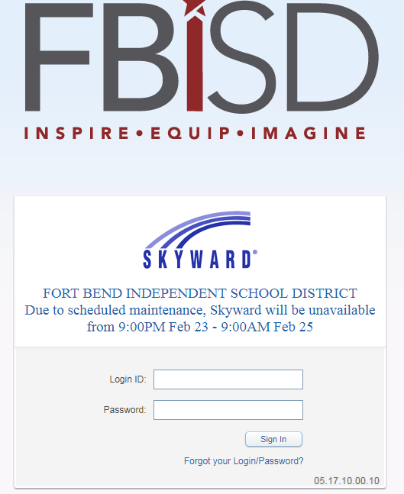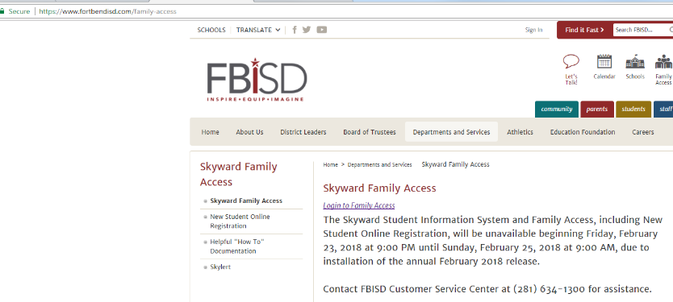

1. 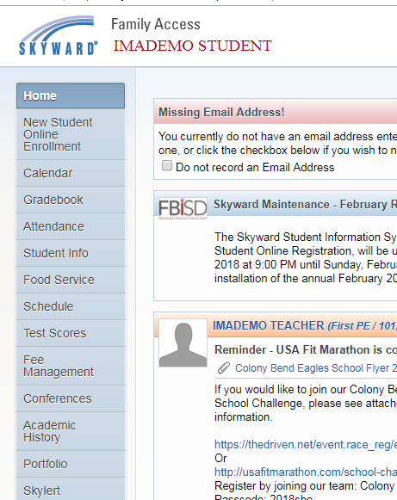Select Portfolio from the menu on the lefthand side of the screen.
2. Select Renaissance 360 Parent Score Report 2019-2020 to view your student’s score report. The file will open as a PDF.

